What does a team manager do?
The adult team manager may be a parent, relative, or anyone over the age of 18 who will serve as a liaison between the team and the libraries. The team manager is responsible for filling out the registration form, keeping the team members motivated, arranging meetings with their team (if desired) and ensuring that all the team members arrive at the Battle by 5:45 pm. Team managers also assist during the Battle.

What is the procedure for the Battle?
The Battle will be held Thursday, March 28, 2019 at the Chartiers Valley Intermediate School. Team members must arrive by 5:45 pm. The Battle starts at 6:00 pm. There are two rounds. Each round will consist of 10 questions…there is one question per book (tie breaker questions will be used only if necessary). The moderator will read a question. The team will have 30 seconds to decide and write an answer. The answer to each question will be a book title and the author’s last name.

Each question is worth a possible 5 points:
- 4 points for a correct book title
- 1 point for the correct author’s last name.
Answers must be spelled correctly to receive points. Answers must be written exactly as indicated on
“Answer Sheet.”

Registration deadline is: February 28, 2019
Questions? Call!
Chartiers Valley’s Eighth Annual BATTLE OF THE BOOKS Intermediate (Grade 4 & 5)
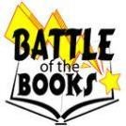Thursday, March 28, 2019 @ 6:00 pm

What is Battle of the Books?
The Battle of the Books is a program designed to encourage reading and give recognition to those who like to read. All team members read from the same list of selected books (see inside). They then compete with other teams by answering questions based on the books.

Who may participate?
Students from Chartiers Valley in 4th and 5th grades may compete. Participants must organize their own teams of four or five students and submit a registration form to Scott or Bridgeville Public Library. Each team must have an adult manager.

Registration
Registration deadline is February 28, 2019. Registration forms may be picked up or downloaded at participating sites. Sponsored by Scott & Bridgeville Public Libraries.

How to prepare:
Plan a strategy, read books from the list provided, memorize the way titles & authors must be written for the battle, choose a team name and design shirts or costumes if you want.

Chris Taylor
Scott Library
412-429-5380 taylorc3@einetwork.net
Karen Verduci
Bridgeville Library
412-221-3737 verducik@einetwork.net
Win a trophy or certificate for participating.
Win a special prize for best costume.
HAVE FUN!

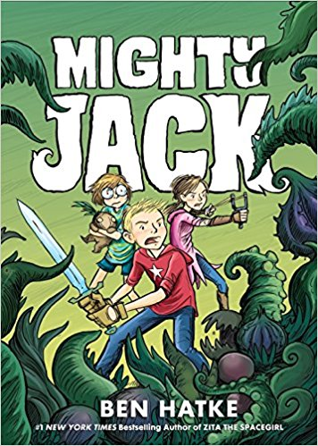
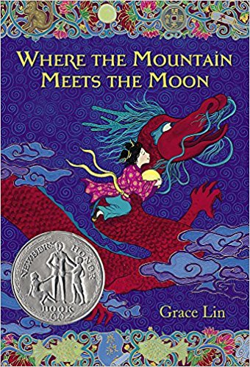
Where the Mountain Meets the Moon by Grace Lin
Pub. 2012 --- 320 pages
Minli, an adventurous girl from a poor village, buys a magical goldfish and then joins a dragon on a quest to find the Old Man of the Moon in hopes of discovering how to change her family's fortune.

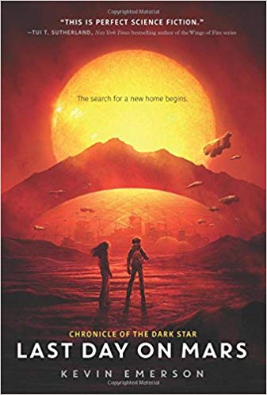
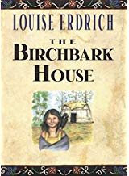
Last Day on Mars by Kevin Emerson
Pub. 2018 --- 352 pages
While waiting to leave Mars before it burns up just as Earth did, Liam and his friend Phoebe discover some facts about time and space and realize that the human race is just one of the races trying to survive in space.

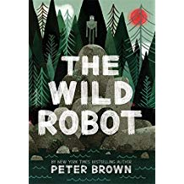

The Wild Robot by Peter Brown
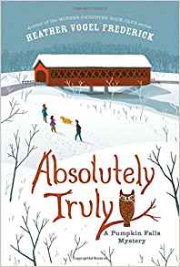
Pub. 2016 --- 288 pages
Roz the robot discovers that she is alone on a remote, wild island with no memory of where she is from or why she is there. Her only hope of survival is to try to learn about her new environment from the island's hostile inhabitants.
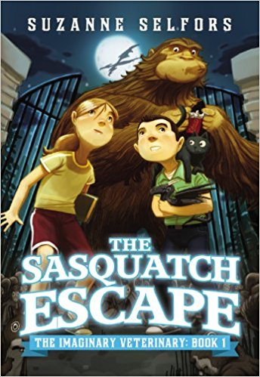
Untamed: The Wild Life of Jane Goodall by Anita Silvey
Pub. 2015 --- 96 pages
This biography for children traces Goodall's life. Each chapter also focuses on two or more of the chimpanzees that she observed, with information in sidebars about these particular animals.

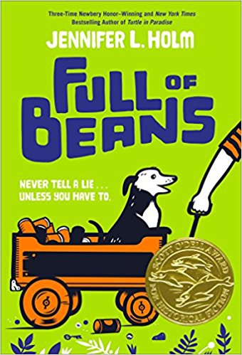
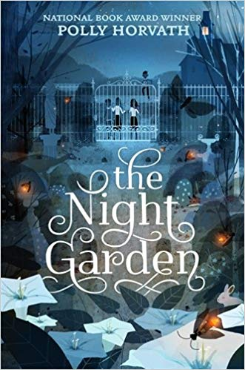
Full of Beans by Jennifer L. Holm
Pub. 2018 --- 224 pages
Ten-year-old Beans Curry, a member of the Keepsies, the best marble playing gang in Depression-era Key West, Florida, engages in various schemes to earn money while New Dealers from Washington, DC, arrive to turn run-down Key West into a tourist resort.

Mighty Jack by Ben Hatke
Pub. 2016 --- 208 pages
Summer is when Jack's single mom takes a second job and leaves him at home with his autistic kid sister, Maddy. After trading for some seeds at a flea market, what starts as a normal little garden quickly grows into a wild, magical jungle.
.

The Birchbark House by Louise Erdrich
Pub. 2002 --- 244 pages
Omakayas, a seven-year-old Native American girl of the Ojibwa tribe, lives through the joys of summer and the perils of winter on an island in Lake Superior in 1847.

Absolutely Truly by Heather Vogel Frederick
Pub. 2015 --- 368 pages
Twelve-year-old Truly Lovejoy's family moves to a small town to take over a bookstore. Soon, she has to solve two mysteries involving a missing book and an undelivered letter.

The Sasquatch Escape by Suzanne Selfors
Pub. 2013 --- 240 pages
Spending the summer in his grandfather's rundown town, ten-year-old Ben meets an adventurous local girl and together they learn that the town's veterinarian runs a secret hospital for imaginary creatures.

The Night Garden by Polly Horvath
Pub. 2017 --- 304 pages
It is spring 1945, and 12-year-old Franny's quiet existence on a Vancouver Island farm is interrupted by a series of unsettling events. Does her father's mysterious wish-granting garden hold the key to getting everyone out of trouble?

