What does a team manager do?
The team manager will serve as a liaison between the team and the libraries. The team manager is responsible for filling out the registration form, keeping the team members motivated, and arranging meetings with their team. Team managers also assist during the Battle by relaying answer sheets to the judges.

What is the procedure for the Battle?
The Battle will be held Tuesday, March 20, 2018 at the Chartiers Valley Middle School at 1:00 PM. Team members can be dressed alike if they choose. There are 3 rounds. Each round consists of 5 questions, or 1 question per book (tie breaker questions will be used only if necessary). The moderator will read a question. The team will have 30 seconds to decide and write an answer. The answer to each question will be a book title and the author’s last name.

Each question is worth a possible 5 points:
- 4 points for a correct book title
- 1 point for the correct author’s last name.
Answers must be spelled correctly to receive points.
Answers must be written exactly as indicated on “Answer Sheet.”

Registration deadline is: February 27, 2018
Questions? Call!
Chris Taylor
Scott Library
412-429-5380
taylorc3@einetwork.net
Karen Verduci
Bridgeville Library
412-221-3737
verducik@einetwork.net

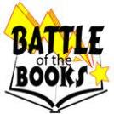
Chartiers Valley’s Fifth Annual
BATTLE OF THE BOOKS
Middle (Grade 6, 7 & 8)
Tuesday, March 20, 2018 @ 1:00 pm
Questions? Call!
Sherry Small Karen Verduci
Scott Library Bridgeville Library
412-429-5380 412-221-3737
smalls@einetwork.net verducik@einetwork.net
What is Battle of the Books?
The Battle of the Books is a program designed to encourage reading and give recognition to those who like to read. All team members read from the same list of selected books. They then compete with other teams by answering questions based on the books.

Who may participate?
Students from Chartiers Valley in 6, 7 & 8 grade may compete. Participants must organize their own teams of two or three students and submit a registration form to Scott or Bridgeville Public Library. Each team must select a manager.

Registration
Registration deadline is February 27, 2018. Registration forms may be picked up or downloaded at participating sites. Sponsored by Scott & Bridgeville Public Libraries.

How to prepare:
Plan a strategy, read books from the list provided, memorize the way titles & authors must be written for the battle, choose a team name and design shirts or costumes if you want.

Win a trophy or certificate for participating. Have fun!
Ender’s Game
by Orson Scott Card
Pub.1985 (AR 5.5) pages 324

Andrew "Ender" Wiggin thinks he is playing computer games. But in reality he is being trained to be the military genius that the planet needs in its all-out war with an alien enemy.

The Hobbit
by J.R.R. Tolkien
Pub. 1937 (AR 6.6) pages 330

Bilbo Baggins, a respectable, well-to-do hobbit, lives comfortably in his hobbit-hole until the day the wandering wizard Gandalf chooses him to take part in an adventure from which he may never return.

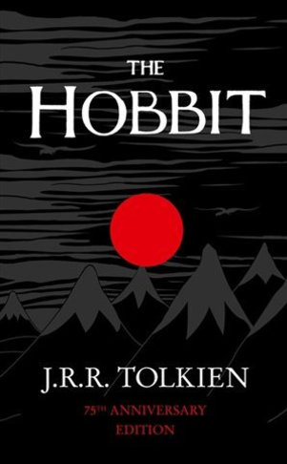
Fever 1793
by Laurie Halse Anderson
Pub. 2000 (AR 4.4) pages 251

In 1793 Philadelphia, fourteen-year-old Matilda Cook, separated from her sick mother, learns about perseverance and self-reliance when she is forced to cope with the horrors of a yellow fever epidemic.

I Kill the Mockingbird
by Paul Acampora
Pub. 2014 (AR 4.1) pages 166

When best friends Lucy, Elena, and Michael receive their summer reading list, they are excited to see To Kill A Mockingbird included. But not everyone in their class shares the same enthusiasm.

Serafina and the Black Cloak
by Robert Beatty
Pub. 2014 (AR 4.3) pages 226

In 1899, a twelve-year-old girl living secretly on North Carolina's Biltmore Estate, teams up with the estate owner's young nephew to battle a great evil and, in the process, unlocks the puzzle of her past.

